**<All the values are on a scale of 0-255 where 0-Black , 255-White>**

**RGB value for Philips Spectra ::**

**[113.60776017 50.87541778 15.39309784]**

Colour Corresponding to above RGB value is :

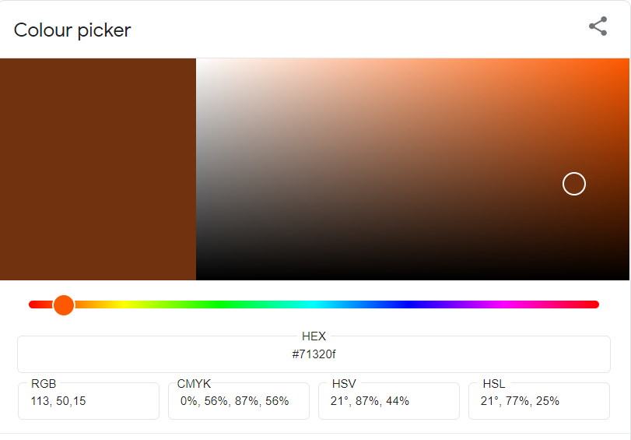

**RGB value for silvania Spectra::**

**[175.12174592 99.97252036 33.24288174]**

Colour Corresponding to above RGB value is : 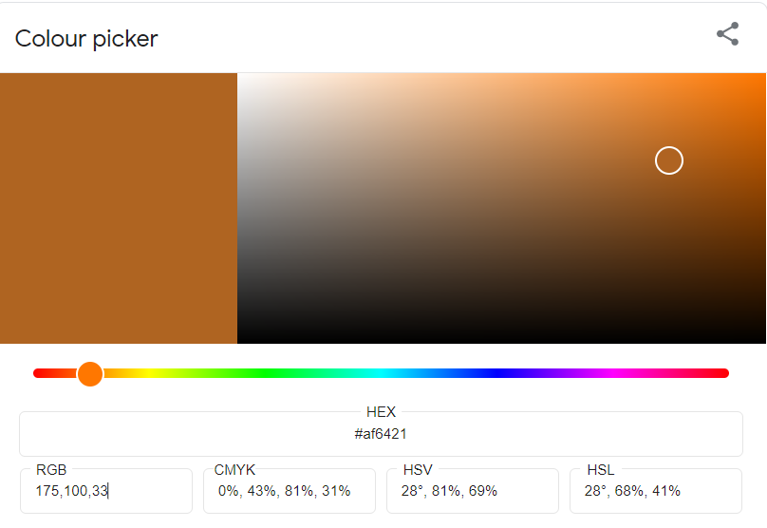

This is clearly visible that for Philips and silvania spectra even though the colour are different but they differs in their brightness not chromaticity. They both are different shades of brown hence they have the same chromaticity just brightness is different.

In both the cases it is clear from the RGB values that red colour is same in both the cases while both green and blue are almost double in silvania.

**RGB value for Uniform Spectra::**

**[255. 255. 255.]**

Colour Corresponding to above RGB value is :

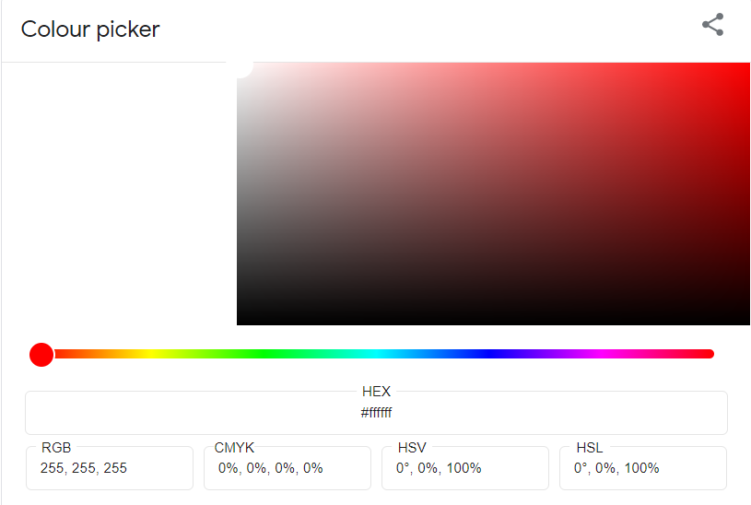

For Uniform Spectra the colour is uniformly spread across all the wavelengths hence the colour is pure white.

**RGB value for uniform spectra under varying reflectance::**

**[129.19097488 196.17509735 187.79257555]**

Colour Corresponding to above RGB value is :

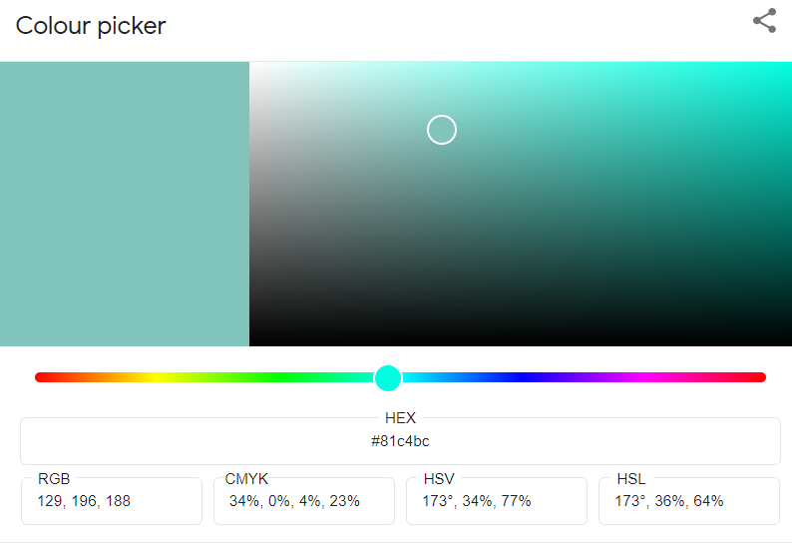

This shows that even if the illumination is uniform over all wavelength if reflectance is varying then also the object will not be seen as pure white.

This colour is more on cyan side.